School of Computing 

COMP*<XXXX>* Scoping and Planning Document

|  |  |
| --- | --- |
| **Student Name: Matthew Watson** | |
| **Programme of Study: IT** | |
| **Provisional Title of Project:** NHS01 The Leeds Method of Management antibiotic app. | |
| **Name of External Company** (if any)**: NHS** | |
| **Supervisor Name: Brandon Bennett** | |
| **Type of Project: Software Product.** | |
| ***NOTE to student****: ensure you have followed the instructions in the VLE for the writing of this report and you have discussed the content with the supervisor well in advance of the deadline for submission.*  ***An electronic version*** *of this report in pdf must also be submitted via the appropriate module folder in the VLE; with filename of the format*  *<surname><year>-MPR ( e.g. SMITH15-MPR.pdf)* | |
| **Signature of Student:** | **Date:** |
| **Assessor** *(leave blank)***:** | |
|  | |

Contents

2 Introduction to project 1

2.1 Problem statement 1

2.2 Possible solution 1

2.2.1 Figure one. 2

2.3 How to demonstrate the quality of the solution 3

3 Scope for this project 3

3.1 Aim 3

3.2 Objectives 3

3.2.1 Must Have: 4

3.2.2 Should Have: 4

3.2.3 Could Have: 4

2.3 Deliverables 4

4 Project schedule 5

4.1 Methodology 5

4.2 Tasks, milestones and timeline 5

4.3 Risk assessment 5

5 References 6

5.1 Appendix A. How ethical issues are addressed 7

# Introduction to project

The reason for this project is to create mobile applications for use by health care professionals to look up treatments for Lung infections. People with cystic fibrosis are vulnerable to lung infections that are usually harmless to healthy people. Cross-infection can be deadly to people with cystic fibrosis this means they need extra care and need quick treatment to make sure they have a better quality of life [1]. To treat these infections combinations of toxic antibiotics have to be used. Doctors can sometimes struggle to find information quickly about choosing the right antibiotics for a specific pathogen. The main aim of the mobile applications is to allow fast access of this information while working in hospitals where there may be no internet connection thus making it hard to get the information. The mobile application update when a connection is present then will store this information on the device to be used even if there is no internet connection. This will enable doctors to have a quick reference guide on hand.

## Problem statement

The problem is bad internet connectivity in hospitals making it hard to for doctors to have quick access to information. This particular problem is the access to information on antibiotics to treat lung infections. There is a need for a quick reference guide on a mobile device that can be updated by an expert. The application needs to update when a connection is present but work offline. There needs to be an admin system to allow an expert to update the information on the mobile applications.

## Possible solution

A possible solution to this is to create an IOS and possibly an Android application with administration system and server. This project relies on the modules; Distributed Systems, Mobile Development, Core Programming, Network and IT management, Software engineering, Graphical User Interfaces and Usability Design. There is a lot of debate over which operating system is more popular but all agree that IOS and Android hold most of the market in comparison with Windows Phone, Blackberry etc.[2][3]. Part of the solution is to create a RESTful server application to handle the updating and storage of the information. The final part of the solution will be a website to handle the administration of the data on the RESTful server with a secure login to make sure only experts have access to edit this critical information. A diagram of the solution is shown below in figure one.

### Figure one.

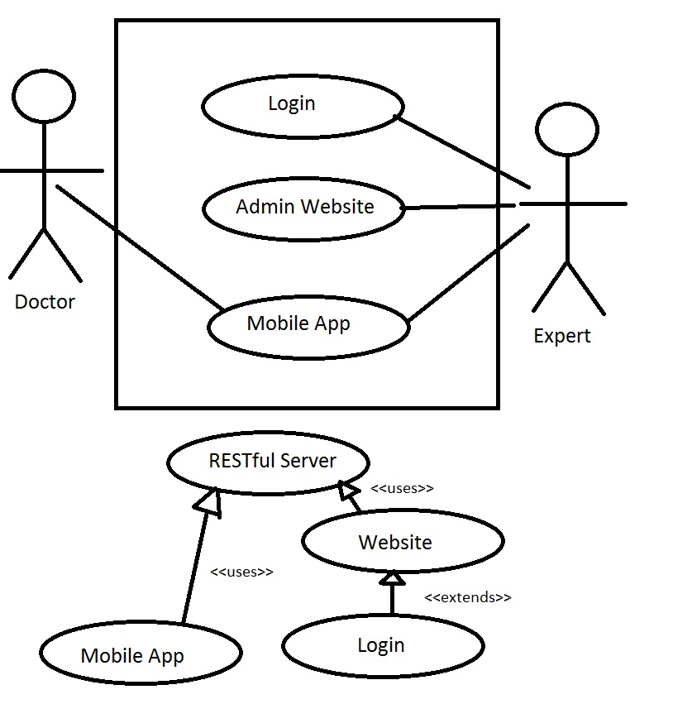

The application should be able to display all the critical information at a glance while offering further information on request.

The method of the mobile app solution follows the following steps:

* Mobile application checks for internet connection.
* If connection exists asks for an update using a get request to the RESTful web service.
* The RESTful server parses a structured XML file back to the app which contains all the details of the antibiotic objects and pathogen objects.
* The XML file is then translated by the app to create the objects for the app to display and use.

The method of the admin application or web app follows the following steps:

* The login is checked to make sure only an expert can edit the data to be shown on the app.
* The website uses a get request from the RESTful web service to current the current version of the data and displays all the objects in a readable manner. If non-exists it will ask for the expert to create one.
* The admin app will then ask if the expert wants to edit or create the data.
* The admin app display will be a set of fields that can be filled in either about an antibiotic or a pathogen this data is used to create the objects. It should be structured in such a way that it’s easy for an expert to just “fill in the gaps”. This should just display common properties of the drug or pathogen that can create the objects for the app.
* Once the data has been created or edited the app will then post or update the server to have the most up to date data this will be parsed in XML like the app receives the information.

## Why REST?

Having a RESTful layer means that any application from any operating system can communicate with the server meaning that if needed other developers can look at the API and create their own app that displays the data the way they want it. REST is stateless meaning doesn’t rely on traditional methods of communicating with a server as it doesn’t create a session of persistent connections, it just uses HTTP perform operations on a web service. The benefit of this is speed and scalability as the application can just use a URI to get the exact data it wants without having to follow server protocols and rules or search though a database for data. Another advantage is loose coupling which means it can be platform independent as HTTP can communicate with mostly all devices that can connect to the internet. The client wants this system to be used much after I have finished the system so this is the best way in my opinion for the system to be used easily. This is because if the app becomes outdated, any developer can just read the API and get the human readable data to be used in their app to be used any way they want. This data will be in XML so any platform can use the data to display the information.

## Why is the main focus IOS, for the mobile App?

The main reason for focusing on IOS is because the client believes this is what most of the students will want to use but an Android app will be strived for if possible. Another good reason to develop IOS is because of the amount of devices you create the app for is very limited, just versions of IPhone/IPad. This makes it easier to test and create interfaces as you are only doing it for a few devices unlike Android which has many different companies such as (HTC, Samsung, Sony etc.) which all have many versions of their devices with varying screen sizes and different versions of the operating systems [5]. As this is quite a short term project IOS definitely seems like the best solution for this reason alone as it will be much faster and safer to create an high quality application that works on IOS devices. If there is time at the end an Android application will be made to a popular device and screen size but catering to all the devices on Android is out of the scope of this project.

## How to demonstrate the quality of the solution

The success of the project will be judged on if the doctors can quickly find the information without guidance. The code of the app should be easily readable and commented to allow other developers to develop it further. The expert should be able to easily understand how to fill in the information. The API should be well documented so others can make apps that can communicate with the server easily. However the admin application should only be able to be used by an authorised person so the post, update and delete requests should be restricted and secure. The application should display the correct data and be easily digestible.

# Scope for this project

The project will deliver a mobile application in IOS and possibly Android with the ability to update over the internet but be used offline. The project will also deliver an admin system that the updates can be easily created without needing knowledge of what is going on in the background. The admin system will be a webpage accessing a RESTful server. The mobile applications will also use the RESTful server to update. The main clientele of the app will be student doctors, other doctors needing this information and the client who requested the app. This app will be released on the app store, if possible, so many others interested in the field may also consume the information.

## Aim

The aim is to create mobile applications that are easy to use and enable health care professionals to quickly access information about antibiotics and pathogens. Also to make sure the system has a long life span and could be expanded to provide information on other types of drugs and diseases. This system should be a generic concept that could be applied to any set of drug and pathogens so could be used widely by health care professionals and people interested in the field.

## Objectives

Major steps of the project:

1. Gather requirements and background research of mobile applications, project management. The chosen operating systems are Apple and probably Android, this will have to be discussed to show details of the operating systems and performance information.
2. Comparison of other medical mobile applications, such as UI, performance and possible ethical issues. Comparison of web services versus standard server client relationship.
3. Design the mobile application and plan the coding process then implement.
4. Design server and admin interface, plan coding process. This could be a standalone application or website.
5. Test Applications and perform evaluation. Add extras such as Android App or Graphics.

### Must Have:

* IOS Mobile application with ability to operate with no internet connection but update when one is present.
* Way to update information on Mobile application, a server to connect to. This server needs to be homogeneous, have the ability to communicate with various applications on different operating systems and devices.
* Administration system that is easy to create update information for the Mobile Applications, a website system with secure login for example.

### Should Have:

* Android Mobile application with ability to operate with no internet connection but update when one is present.
* Available on both Google Play and Apple App Store.
* Administration website so it can be accessed from anywhere.

### Could Have:

* Graphics to make the application more aesthetically pleasing.
* Cacheable website to be able to use on operating systems that have not been developed in this project e.g. Windows Phone, Blackberry, Desktop computers running various operating systems.

### 2.3 Deliverables

Comparison of server to mobile communication. This is to show the reason why I have chosen a REST web service approach and justify why I think it is the best way to implement the server side of the application.

Design documentation of the design process of the coding and user interface. This will be evidence of refining the requirements with the client to make sure everything is in the app that needs to be.

Apple mobile app code, working application and documentation on how it works with the API.

The administration interface and application with code, documentation and how it works with the API.

The RESTful server/web service with API. The documentation to this is a crucial part of the system as well as the code and instructions on how to use it.

If time allows the Android App with documentation.

# Project schedule

## Methodology

This project is planned to follow and agile methodology having each iteration producing some working software. The reason for doing this is that working with a client plans can change often and following a waterfall approach it doesn’t allow for changes to the plan during implementation. I want the ability to cater to the client’s needs and change the project when needed to make sure the requirements they need are being met.

## Tasks, milestones and timeline

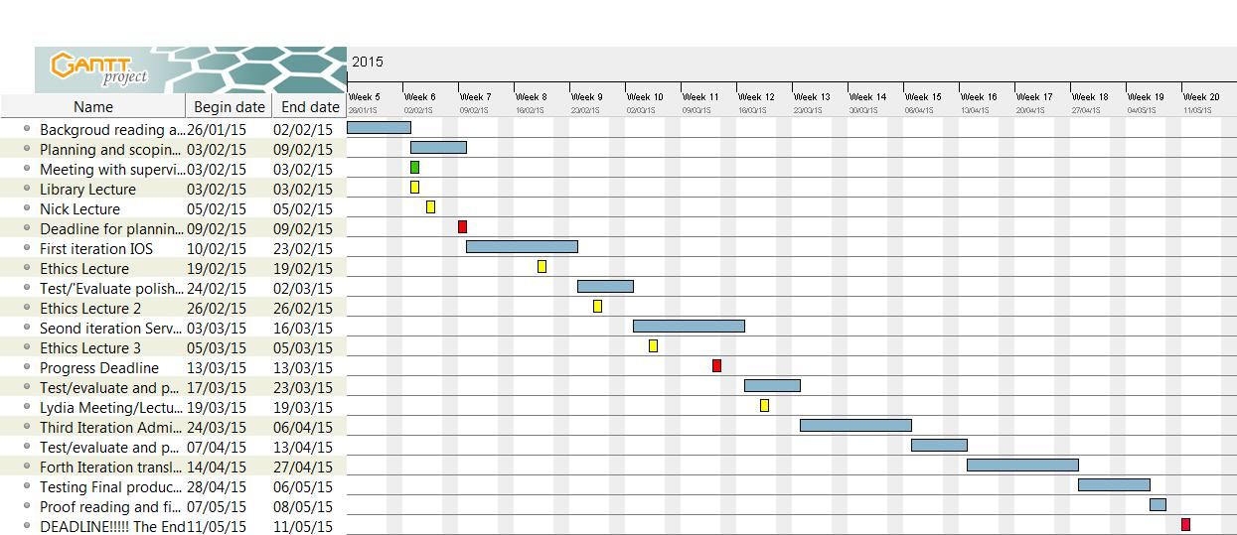

## Risk assessment

There are many risks involved with this project as it relies on many outside factors such as the application stores and the client’s needs for the project. An example of this is if the client is unavailable for a long period of time it might be hard to get all the criteria needed to make the application successful or even test it with the servers he wants to use. To minimize this risk we are having lots of meetings at the start to make sure there is good understanding of the requirements for the project. Thus meaning if the client is unavailable the project can proceed without client input. The client is also providing the servers so timing and planning will need to be perfect to make sure the servers are able to run my applications etc. as well as all the security procedures that will be needed. This is quite a big risk and may cause problems later on in the project but to minimize the risk the client has specified I can choose what type of server I want and he will get it minimizing potential compatibly issues if I did not know what server was going to be used.

There is also a major security risk as this application is going to be available publicly and handles data that can affect people’s lives. For example if a malicious user managed to get past the security of the log in and have access the data they could change crucial information about the dosages etc. which may lead to inexperienced doctors providing the fatal doses of the drugs. This means the security will have to be tested thoroughly to make sure the data for the app is secure as possible.

Below is a risk assessment table to give more details of the risks.

|  |  |  |  |  |
| --- | --- | --- | --- | --- |
| Risk | Probability of Risk | Amount of impact on project | Preventative Measures | Stakeholders affected |
| Malicious Users corrupting the data or breaking the application. | Low | High | Security features such as a log in feature and server not allowing any requests other than GET from the mobile app. | People using the app. Creator. Client. Application store. University. |
| Budget costs of servers and publishing the application on the App stores being too high to successfully implement. | Low | High | Appropriate planning during the final phase of the project. Once everything is implemented and working locally costing can be predicted of how to publish it on the system in the hospital and on the application store(s). This will help keep the costs down to be able to implement the system efficiently. | Client. Creator. |
| Client Unavailable for some stages of implementation and testing. | Medium | Low | Planning around the client’s busy schedule to make sure requirements are met. Get most of the key requirements at the beginning the “must haves” to make sure all the important functional features are in the project. | Client. Creator. |
| Data is not correct in application | Low | High | As some doctors may be prescribing toxic drugs based on information in this application is key that is validated and checked. Failing to do this may result in overdoses of drugs leading to illness even death. | People using the app. Creator. Client. Application store. University. |

# References

**[1] Cysticfibrosis.org.uk. 'Cross-Infection - Cystic Fibrosis Trust'. N.p., 2015. Web. 29 Jan. 2015.**

**[2] Arthur, Charles. 'Three Graphs To Stop Smartphone Fans Fretting About 'Market Share''. The Guardian. N.p., 2014. Web. 29 Jan. 2015.**

**[3]Marketshare.hitslink.com. 'Operating System Market Share'. N.p., 2015. Web. 29 Jan. 2015.**

**[4]Taylor, Bryan. 'What Are The Advantages/Disadvantages Of Using REST API Over Native Libraries? - Quora'. Quora.com. N.p., 2015. Web. 10 Feb. 2015.**

**[5]** **Hata, Kosuke. 'Why Do Mobile App Developers Tend To Build On IOS First Rather Than Other Platforms Like Android? - Quora'. Quora.com. N.p., 2015. Web. 11 Feb. 2015.**

# Appendix A. How ethical issues are addressed

## Working with NHS member of Staff and other members of the medical faculty.

The client works for the NHS, no personal details of the client will be published in this report. No personal details of any other member of the faculty, students or otherwise, testing the applications will be published. This application does not deal with patient data so that ethical issue does not need to be addressed.

## The Data in the Application can affect people’s lives

As doctors may be using this application to prescribe drugs the information in the application will have to be correct and a disclaimer will be shown not to base all judgement on the information about the drugs in the application. Links will be put into the application to the website where the information is being held to allow additional confirmation when an internet connection is present.